A PROJECT REPORT

Submitted in partial fulfillment of the requirements for the award of the degree of

Bachelor of Technology
In

COMPUTER SCIENCE AND ENGINEERING BY
S.SATHWICK SK.TABREEZ
(18331A05C6) (18331A05E2) B.YOGESH R.VINAY
(18331A05D4) (19335A0514 )

Under the Supervision of
Mr. R. RAVI KUMAR
Assistant Professor

Department of Computer Science and Engineering

MVGR COLLEGE OF ENGINEERING (AUTONOMOUS)
VIZIANAGARAM-535005, AP (INDIA)
(Accredited by NBA, NAAC, and Permanently Affiliated to Jawaharlal Nehru

Technological University Kakinada)
APRIL, 2020
MAHARAJ VIJAYARAM GAJAPATHI RAJ COLLEGE OF ENGINEERING
(Autonomous)
Vizianagaram

CERTIFICATE

This is to certify that the project report entitled "LIBRARY MANAGEMENT SYSTEM " being submitted by Mr.SATHWICK , Mr.VINAY, Mr.TABREEZ, Mr.YOGESH bearing register number 18331A05C6, 19335A0514, 18331A05E2, 18331A05D4 respectively, in partial fulfillment for the award of the degree of "Bachelor of Technology" in Computer Science and Engineering is a record of bonafide work done by her under my supervision during the academic year 2019-2020.
Supervisor HOD CSE
Mr. R. Ravi Kumar Dr. C. Kalyana Chakravarthy Assistant Professor

TABLE OF CONTENTS
S.no | content | Pg.no.
1 | Introduction | 3
2 | Data types | 4
3 | Data Requirements    Entities  Attributes  Relationships - cardinality | 5-6
4 | Entity Relationship Diagram | 7
5 | Creating database using MySQL | 8-10
6 | Test-case Queries | 11
7 | conclusion | 12
8 | References | 13
1.INTRODUCTION:
A library is a collection of organized information and resources which is made accessible to a well-defined community for borrowing or reference sake. The collection of the resources and information are provided in digital or physical format in either a building/room or in a virtual space or even both. Library’s resources and collections may include newspapers, books, films, prints, maps, CDs, tapes, videotapes, microform, database etc. The main aim of this system is to develop a new programmed system that will conveying ever lasting solution to the manual base operations and to make available a channel through which staff can maintain the record easily and customers can access the information about the library at whatever place they might find themselves. Library Management System allows the user to store the book details and the customer details. The system is strong enough to withstand regressive yearly operations under conditions where the database is maintained and cleared over a certain time of span. The implementation of the system in the organization will considerably reduce data entry, time and also provide readily calculated reports.

PURPOSE:
- The purpose of this project is to provide a friendly environment to maintain the details of books and library members.
- The main purpose of this project is to maintain easy circulation system using computers and to provide different reports.
- Improved user service through greater access to accurate information.
- Due to computerized information it reduces the risk of paper work such as file lost, file damaged and time consuming. It can help user to manage the transaction or record more effectively and timesaving.
OBJECTIVE: - It keeps track of all the information about the books in the library, their cost, status and total number of books available in the Library. The user will find it easy in this automated system rather than using the manual writing system. The system contains a database where all the information will be stored safely

2. Data types and its description
- Integer: one optional sign character (+ or -) followed by at least one digit (0-9). Leading and trailing blanks are ignored. No other character is allowed.
- Varchar: It is used to store alpha numeric characters. In this data type we can set the maximum number of characters up to 8000 ranges by defaults SQL server will set the size to 50 characters range.
- Date: The DATE data type accepts date values. No parameters are required when declaring a DATE data type. Date values should be specified in the form: YYYY-MMDD. However, Point Base will also accept single digits entries for month and day values. 4. Time: The TIME data type accepts time values. No parameters are required when declaring a TIME data type. Date values should be specified in the form: HH:MM: SS.
An optional fractional value can be used to represent nanoseconds.

3. Data Requirements
Entities
- BRANCH
- EMPLOYEE
- CUSTOMER
- ISSUE STATUS
- RETURN STATUS
- BOOKS
Attributes
❖ BRANCH
- Manager_id
- Branch_id
- Address
▪ Contact_no
▪ Branch_h_no
▪ Street
▪ City
▪ State
▪ Zipcode
❖ CUSTOMER
- Customer_id
- Books_issued
- Name
- Address
- Registration_date
❖ ISSUE STATUS
- Issue_book_name
- Issue_id
- Issue_date
- ISBN
- Customer_id
❖ RETURN STATUS
- Return_id
- Return_date
- Customer_id
- Return_book_name
- ISBN
❖ BOOKS
- ISBN
- Title
- Category
- Rental_price
- Author
- Publisher
- Status

RELATIONSHIPS - CARDINALITY
MANAGER manages the BRANCH (1 - N)
CUSTOMER registers in the respective BRANCH (N – 1)
CUSTOMER issues BOOKS (1 – N)
CUSTOMER returns BOOKS (N – 1)
EMPLOYEE updates BOOKS (N – N

4. Entity-Relationship-DIAGRAM
Entity Relationship Diagram is used in modern database software engineering to illustrate logical structure of database. It is a relational schema database modelling method used to Model a system and approach. This approach commonly used in database design. The diagram created using this method is called ER-diagram. The ERdiagram depicts the various relationships among entities, considering each object as entity. Entity is represented as rectangle shape and relationship represented as diamond shape. It depicts the relationship between data object. The ER-diagram is the notation that is used to conduct the data modelling activity

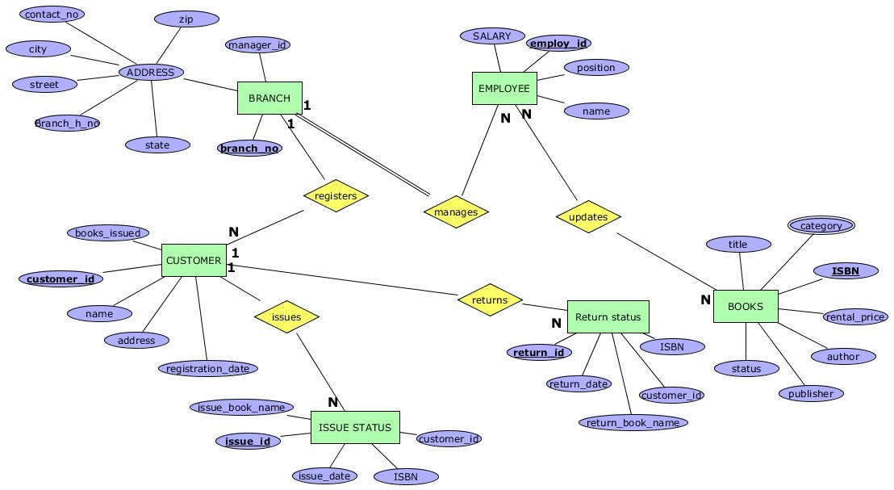

5. CREATING DATABASE USING MYSQL
mysql> create database libproject; mysql> use libproject; Database changed mysql> CREATE TABLE BOOKS(ISBN int(100) not null,book_title varchar(50) not null,category varchar(50) not null,rental_price int(10) not null,status varchar(50),author varchar(50) not null,publisher varchar(50) not null,primary key(ISBN)) ; Query OK, 0 rows affected (1.44 sec) mysql> CREATE TABLE EMPLOYEE(employ_id int(10) not null,employ_name varchar(50) not null,position varchar(30) not null,salary int(10) not null,primary key(employ_id)); Query OK, 0 rows affected (0.35 sec) mysql> create table customer(customer_id int(10) not
null,customer_name varchar(50),customer_address varchar(100) not null,registration_date date not null,primary key(customer_id)); Query OK, 0 rows affected (0.38 sec) mysql> create table brach(branch_no int(10) not null,manager_id int(10) not null,branch_address varchar(100) not null,contact_no int(10) not null,primary key(branch_no)); Query OK, 0 rows affected (0.49 sec) mysql> create table issue_status(issue_id int(10) not null,issued_cust int(10) not null,issued_book_name varchar(50) not null,issue_date date not null,isbn_book int(10) not null,primary key(issue_id),constraint foreign key(isbn_book) references BOOKS(ISBN),constraint foreign key(issued_cust) references customer(customer_id)); Query OK, 0 rows affected (0.66 sec) mysql> alter table brach rename branch; Query OK, 0 rows affected (0.50 sec)
mysql> create table return_status(return_id int(10) not null,return_cust int(10) not null,returned_book_name varchar(50) not null,return_date date not null,isbn_book2 int(10) not null,primary key(return_id),constraint foreign key(isbn_book2) references BOOKS(ISBN),constraint foreign key(return_cust) references issue_status(issued_cust));
Query OK, 0 rows affected (0.39 sec)

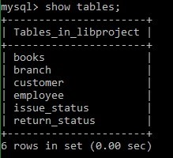

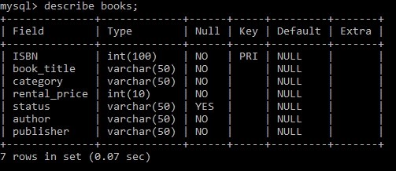

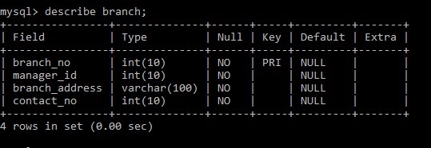

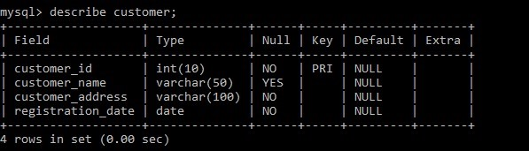

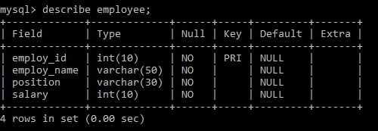

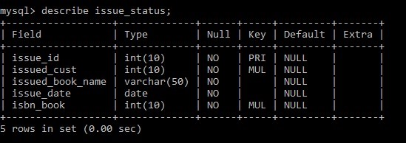

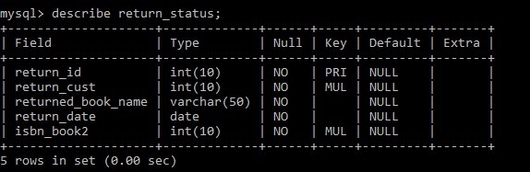
mysql> insert into books
values(1000,'book1','comedy',5,'available','author1','pub1'); Query OK, 1 row affected (0.18 sec) mysql> insert into books
values(1001,'book2','scifi',3,'available','author2','pub2'); Query OK, 1 row affected (0.08 sec)
mysql> insert into books
values(1003,'book3','romance',1,'unavailable','author3','pub3'); Query OK, 1 row affected (0.06 sec) mysql> insert into books
values(1004,'book4','thriller',7,'available','author4','pub4');
Query OK, 1 row affected (0.07 sec)
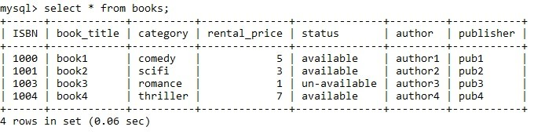
mysql> alter table branch add constraint foreign key(manager_id) references employee(employ_id);
Query OK, 0 rows affected (1.20 sec) Records: 0 Duplicates: 0 Warnings: 0 mysql> insert into employee values(991,'emp1','manager',30000); Query OK, 1 row affected (0.06 sec) mysql> insert into employee values(992,'emp2','worker',10000); Query OK, 1 row affected (0.07 sec) mysql> insert into employee values(993,'emp3','worker',10000); Query OK, 1 row affected (0.05 sec) mysql> insert into employee values(994,'emp4','reader',20000); Query OK, 1 row affected (0.07 sec) mysql> insert into employee values(995,'emp5','assist’,20000);
Query OK, 1 row affected (0.07 sec)
mysql> insert into branch values(1,991,'branch_addr1',987654321);
Query OK, 1 row affected (0.07 sec) mysql> insert into branch values(3,993,'branch_addr3',987654323);
Query OK, 1 row affected (0.09 sec
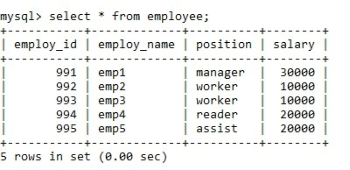
mysql> insert into customer values(11,'cus1','hom1','2008:10:10'); Query OK, 1 row affected (0.07 sec) mysql> insert into customer values(12,'cus2','hom2','2008:03:03'); Query OK, 1 row affected (0.09 sec) mysql> insert into customer values(13,'cus3','hom3','2009:03:03');

mysql> insert into issue_status values(51,12,'book1','2010:01:01',1001);

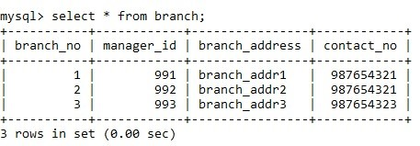

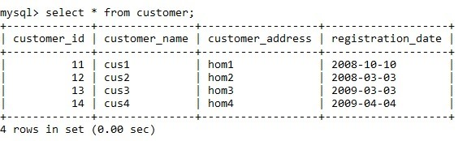
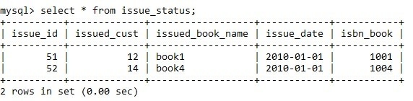
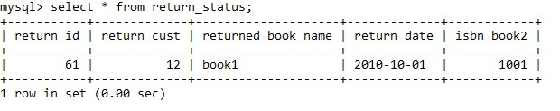

6.TEST QUERIES
- Display the customer name who took the book of type comedy.
Mysql>select customer_name from customer where book_type=’comedy’;
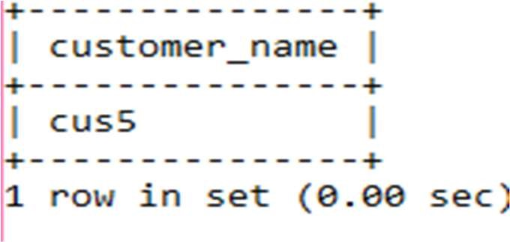

- Display issue id ,issued customer name whose ibsn book number is 1004.
Mysql>select issue_id , issued_cust from issue_status where isbn_book=1004;
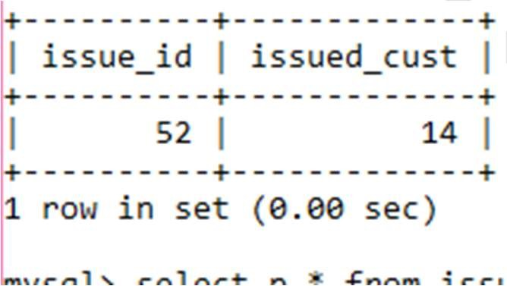

3.Display all contents in issue status table where isbn book of issue table and return table are equal.
Mysql>select p.* from issue_status p, return_status r where p.isbn_book=r.isbn_book2;
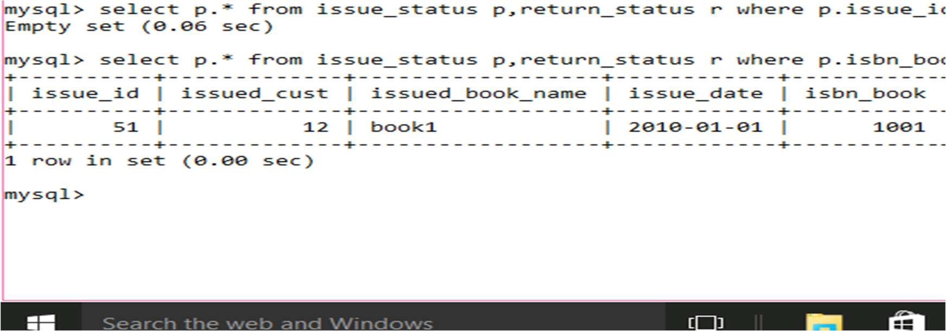

4.Add a column called book type in customer table.
Mysql>alter table customer add book_type varchar(10) not null;
Query ok,4 rows affected(0.37sec)
Records:4 Duplicates:0 Warnings:0
Mysql>describe customer;

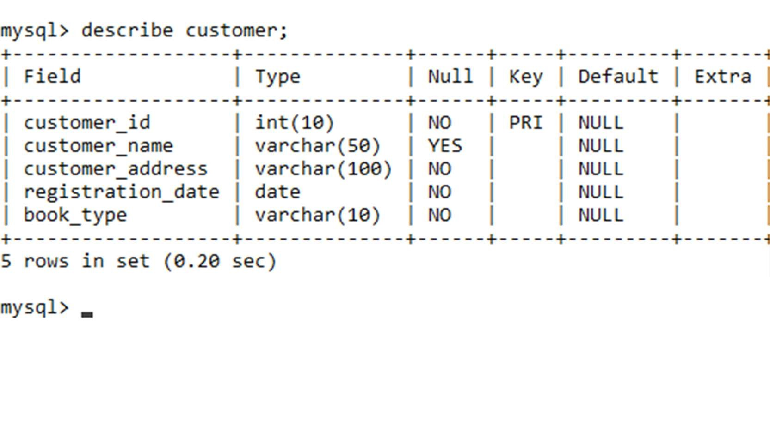

7.CONCLUSION

  - SQL database management application which is very well used in the modern world in organising and manipulating a database.
  - Though SQL doesn’t have the GUI interface like Microsoft access is having and they all manage the database comfortable.
  - Depending on the user or users, if an organisation has multiple users then they should go for SQL server based application.
  - This project shows how to create tables in SQL and how to create simple data manipulation language and data definition language with how to execute them.
  - It also shows how relationships are established with the concepts of primary and foreign key within a table.
  - Lastly, the project shows how queries are created in SQL server, queries like the create command, view, update, alter etc.

